MMC Entertainment

Hit Song analysis

Presented By

Benjamin Hinchman

Jesse Gibbons

Kyle Tolliver

Richard Kung

Shane Mecham

# Analysis Overview

# Hits

Based on our models for the entire dataset, the determining factors are loudness, speechiness, danceability, duration, energy, valence, and tempo. Using these factors provided by Shane, and localizing the comparisons to the past twenty years, we can predict with an Accuracy of 70%, whether a produced song will be considered a 'hit'. If we use the top 25 percentile of popular songs, based on speechiness and loudness alone, we can let you know if it will be a hit. With a precision of 75%, recall of 91%, and an Accuracy of 70%, we feel confident our model will be able to significantly improve the potential to be a popular song.

## Flops

For determining a 'flop', we can, based on the previous two factors, determine with a 62% accuracy, 67% precision, and 87% recall score, whether a song will be a flop or not. Different factors could be adjusted to find more reliable markers, but overall, considering a 'flop' as the bottom 25 percentile of songs listened to, we can safely predict what not to do, in order to avoid a potential "flop."

Historical factors of popularity

# Conclusions and Caveats

In general danceability, duration, valence, energy, speechiness, loudness, and tempo mattered for whether a song would be popular. However these values can fluctuate drastically based on the time period when the song was from. Tempo barely mattered at all in most of the eras so it wouldn’t be a good idea to focus on this feature for creating a song.

[MMC Entertainment produces a lot of rap.](https://sound.mmcentertainments.com/) The Spotify data shows that most rap is within the desirable range for all of these features.

# Figures

|  |  |
| --- | --- |
| Era | Factors from greatest to least |
| 2000-2020 | Danceability, Duration, Valence, Energy, Speechiness |
| 1980-2000 | Loudness, Duration, Energy, Danceability, Speechiness |
| 1960-1980 | Loudness, Duration, Danceability, Speechiness, Tempo |
| 1940-1960 | Valence, Speechiness, Loudness, Duration |
| 1920-1940 | Speechiness, Energy, Loudness, Valence |

The trending features of “hit” songs in two-decade periods

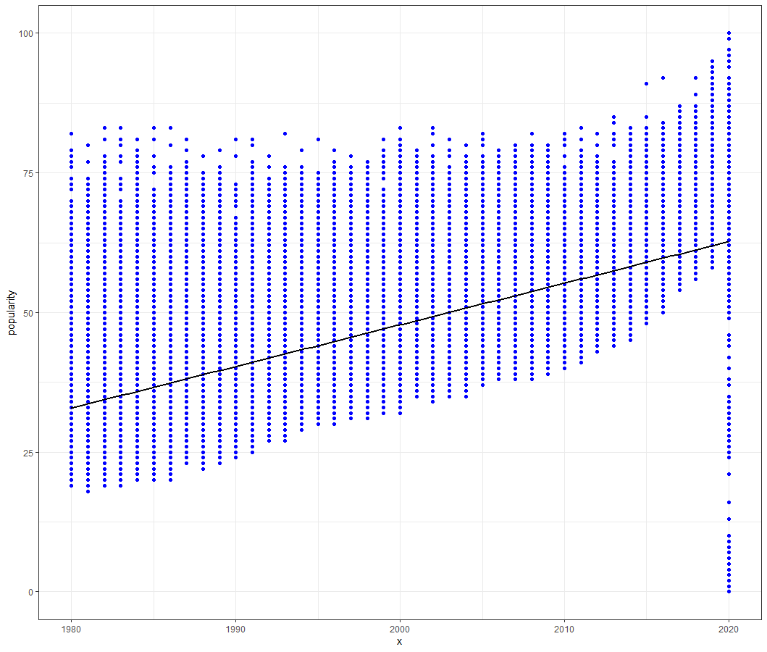

Popularity trend of songs by age

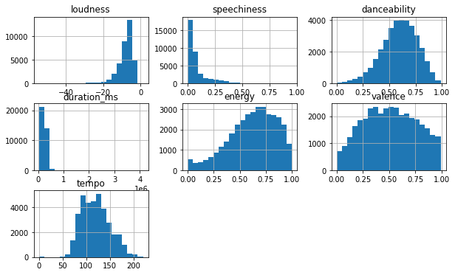

Histograms of hits(above) and flops(below) after 1950

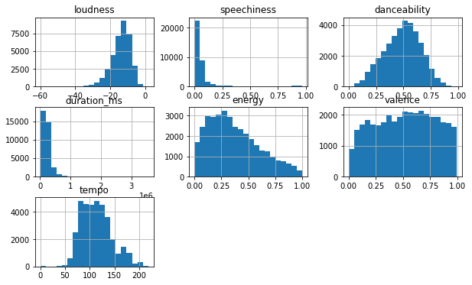

Notebooks Used

<https://colab.research.google.com/drive/1DVHsIbWCDa5Uq7wcglXbKEkBKnQnK9n1?usp=sharing>

<https://colab.research.google.com/drive/1_JgeD7-36mvyPuqE0daBL32YYLItsc6U?usp=sharing>